Title of the Project: -

Student Marks Predictor + Weak Area Detector
Is based on the UCI Student Performance dataset
Prepared by-Arpita panda
Abstract:
This report contains the work done during my one-month internship on the project “Student Marks Predictor + Weak Area Detector” based on the UCI Student Performance dataset. The main aim of this project is to predict student marks and identify weak subject areas using machine learning techniques. The report provides an overview of the tasks completed during the internship period. During this project, I worked on data collection, preprocessing, visualization, and prediction using Python libraries such as Pandas, NumPy, Matplotlib, Seaborn, and Scikit-learn. Various factors like study time, attendance, and previous marks were analyzed to understand their impact on student performance. This internship helped me improve my knowledge of Python programming, machine learning, and data analysis while enhancing my practical and problem-solving skills.

Introduction:
1. Executive Summary
This project builds an intelligent student performance support system. It does not stop at predicting a final score. It also estimates risk, identifies the main weak areas behind the predicted score, and gives actionable improvement guidance. In simple words, the system answers three questions at the same time:
1. What score is the student likely to get?
2. Is the student at low, medium, or high risk?
3. What are the biggest reasons pulling the score down, and what should the student improve first?
That makes the project much stronger than a plain regression model because it moves from prediction to interpretation and from interpretation to recommendation.
So the smart version of the project is this: keep your business idea exactly as it is, but adapt the implementation in one of two ways:
Version A: Use the UCI dataset as your main academic proof-of-concept.
Version B: Build a small custom front-end form with your exact features and train a second model later on your own collected data.
2. Project Objective and Goal
The objective of this project is to use machine learning to estimate a student's expected final marks and automatically detect the major factors affecting performance. The final goal is not only accuracy. The final goal is support, intervention, and improvement.
Core goals of the project:
- Predict final marks as a regression problem.
- Predict pass or fail, or low/medium/high risk, as a classification problem.
- Show which factors are contributing most to the prediction.
- Turn those factors into human-readable weak areas.
- Generate recommendations that help a student improve before the final exam.

Theory:
1.Problem Statement in Plain Language
Suppose a school, tutor, or educational app wants to know which students may underperform by the end of the term. Waiting until the final exam is too late. The system should detect warning signals earlier.
The project therefore solves these practical problems:
1. Estimate future final performance from currently known student-related data.
2. Flag students who are likely to struggle.
3. Explain which factors are associated with lower predicted performance.
4. Suggest priority actions, such as improving attendance or study consistency.
2. Inputs and Outputs of the System
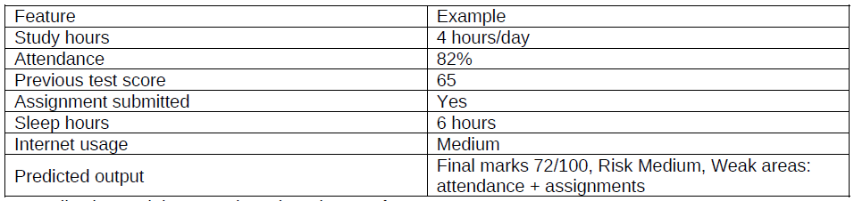
Your proposed user-friendly feature view can look like this
Internally, the model can produce three layers of output:
- Numeric prediction: final marks, for example 72 out of 100.
- Risk label: low, medium, or high.
- Weak area explanation: the top reasons that lowered the predicted outcome.
3.Important Dataset Reality Check
This section is crucial for understanding the project correctly.
The UCI Student Performance dataset is a very good academic dataset, but it does not exactly match every feature in your sample input. The official dataset contains student grades plus demographic, social, and school-related attributes from two Portuguese schools. It includes two subject datasets, Mathematics and Portuguese. It also warns that the final grade G3 is strongly correlated with earlier grades G1 and G2, because those are previous period grades.
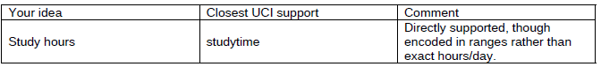
This means the original UCI dataset supports your project idea very well, but with adaptation

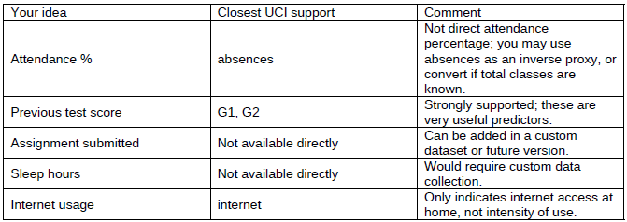

This is not a weakness. It is actually shows that you understand the difference between a business idea and a dataset implementation.
4.What Exactly Are We Predicting?
You can define the project in multiple target formulations. That is one of the reasons the project is rich.
4.1 Regression target
Predict a continuous final score. In the UCI dataset, the natural target is G3, the final grade. In your custom interface, you may rescale it to 100 if you want a more familiar score display.
4.2 Classification target
Create a pass/fail label or a risk band.
- Pass/Fail: predict whether the final score crosses a threshold.
- Risk Level: map predicted marks into categories such as low risk, medium risk, and high risk.
- Support Priority: identify whether intervention is urgent.
4.3 Explanation target
This is not a classical machine learning target. It is a logic layer built on top of the model. After the model predicts a score, we analyze which features pushed the prediction downward and translate them into understandable weak areas.

5. System Architecture
A strong way to describe the project is as a 5-stage pipeline:
1. Data Layer - collect and prepare student data.
2. Prediction Layer - train regression and classification models.
3. Explanation Layer - compute feature importance or per-student contribution.
4. Weak Area Detector - convert important negative factors into weak-area labels.
5. Recommendation Layer - turn those labels into advice.
'This is not only an ML predictor. It is a lightweight decision-support system for academic intervention.'
6.Step-by-Step Project Workflow
6.1 Step 1 - Define the problem clearly
Decide whether you want to predict final marks only, pass/fail only, or both. The best version does both. Also define what the system should optimize for: accuracy, explainability, early intervention, or all three.
6.2 Step 2 - Understand the dataset
Read every column carefully. Separate academic features from demographic and lifestyle features. Identify which columns are available before the final exam and which would cause leakage if used incorrectly.
6.3 Step 3 - Handle the project-design gap
Your ideal form includes attendance percentage, assignments, and sleep hours. The UCI dataset does not provide all of them directly. So document which features are direct, proxied, engineered, or unavailable. This is a maturity signal, not a flaw.
6.4 Step 4 - Select the target
For regression, use G3. For classification, derive pass/fail or risk buckets. Example: low risk >= 75, medium risk 50-74, high risk < 50 after rescaling.
6.5 Step 5 - Prepare the data
Encode categorical variables, scale numerical variables if needed, and separate train, validation, and test sets. Handle columns carefully so that the same transformation is applied to new student inputs.
6.6 Step 6 - Perform exploratory data analysis
Study distributions, correlations, class imbalance, and missing-value behavior. In the official UCI page, the dataset states that missing values are not present. [1] Even then, you should still verify cleanliness in code.
6.7 Step 7 - Build a baseline model
Always start simple. A baseline Linear Regression model is valuable because it gives you interpretability and a benchmark. Never jump directly to a complex model without a baseline.
6.8 Step 8 - Compare better models
For mark prediction, compare Linear Regression and Random Forest Regressor. For pass/fail or risk classification, compare Logistic Regression and Decision Tree. You can also test Random Forest Classifier if you want a stronger but still understandable option.
6.9 Step 9 - Evaluate properly
Use regression metrics such as MAE, RMSE, and R-squared. For classification, use accuracy, precision, recall, F1-score, and confusion matrix. Choose metrics according to your project priority.
6.10 Step 10 - Add explainability
Use feature importance, permutation importance, or coefficient interpretation. If you want a more polished version, add SHAP later, but the first strong version can work with simpler explainability methods.
6.11 Step 11 - Build the weak area detector
Map weak signals into named causes such as poor prior performance, low study time, high absences, or other problem clusters.
6.12 Step 12 - Generate recommendations
If a student is flagged for low study time and high absences, the system should recommend attendance improvement and study scheduling. That final layer makes the project useful.
6.13 Step 13 - Build the user-facing interface
Create a notebook report, Streamlit app, Flask API, or dashboard. A simple web form where a user enters student details and receives prediction + risk + reasons is enough for an impressive project demo.
7. A Very Important Nuance: Data Leakage
This project gives you a chance to discuss one of the most important ideas in practical machine learning: leakage.
In the official dataset, G1 and G2 are earlier grades and are strongly correlated with G3. [1] If your goal is to predict final grade near the end of the academic period, using G1 and G2 is fine. But if your goal is to predict very early and intervene sooner, relying on G1 and G2 may make the project less realistic.
So you can build two versions:
- Version 1 - High-accuracy version: includes G1 and G2.
- Version 2 - Early-warning version: excludes G1 and G2 so that the model relies on earlier behavioral and contextual signals.
This is a very strong design decision to discuss in a report or interview. It shows that you understand that the most accurate model is not always the most useful model
8.Understanding the ML Models Simply
8.1 Linear Regression
A simple model that learns a weighted combination of input factors. It is easy to explain, easy to debug, and gives a solid baseline.
8.2 Random Forest Regressor
This model uses many decision trees and combines them. It usually captures non-linear relationships better than linear regression.
8.3 Logistic Regression
This is a very standard model for pass/fail prediction or risk classification. It is easy to explain and fast to train.
8.4 Decision Tree
A decision tree is visually intuitive. It makes rule-based splits such as 'if absences are high and study time is low, risk is high.' It is good for explanation and storytelling.
8.5 Why simple models are a good choice here
- This project should be understandable to teachers, students, and interviewers.
- Tabular educational datasets often work well with classical ML.
- Simple models help you focus on interpretation rather than complexity.
9. Feature Engineering Ideas
Convert absences into an attendance-style indicator if school calendar information is available.
- Group low-value categories together if rare categories hurt generalization.
- Create prior performance summaries such as average of G1 and G2.
- Create risk flags such as 'very low study time' or 'high absence band'.
A very smart report statement is this: 'Feature engineering here is not only mathematical transformation; it is also semantic alignment between raw dataset fields and human-meaningful student signals.'
10. How the Weak Area Detector Works
This is the heart of your novelty.
A weak area detector is a rule and explanation layer sitting on top of the prediction model. It takes model outputs plus influential features and turns them into understandable causes.
A simple design is:
1. Predict final marks.
2. Rank the most influential features for that student or for the model globally.
3. Select the negative contributors.
4. Map those contributors into named weak areas.
5. Generate a ranked explanation.
Example translation:
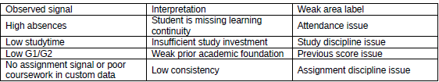

A basic user-facing explanation can then look like this:
- Predicted final marks: 72/100
- Risk level: Medium
- Top reasons for lower score: 1) low attendance, 2) less study time, 3) weak previous test score
That is exactly the kind of output that feels useful rather than merely technical.
11. Designing the Risk Score
Risk score design should be simple and transparent.
One clean approach is mark-based banding:
- Low risk: predicted marks >= 75
- Medium risk: predicted marks between 50 and 74
- High risk: predicted marks < 50
A second approach is hybrid risk scoring:
- Use predicted score.
- Add penalties for very high absences or very low study time.
- Raise risk if multiple warning signals occur together.
The hybrid version is often more intuitive for real-world intervention systems because it looks at both outcome prediction and warning behavior.
12. How to Evaluate the Project Properly
12.1 Regression evaluation
- MAE - average absolute prediction error. Easy to explain.
- RMSE - penalizes larger errors more strongly.
- R-squared - proportion of variance explained by the model.
12.2 Classification evaluation
- Accuracy - overall correctness.
- Precision - when the model flags risk, how often is it right?
- Recall - among students truly at risk, how many did the model catch?
- F1-score - balance between precision and recall.
- Confusion matrix - practical view of correct and incorrect classifications.
12.3 Explanation evaluation
Explanation evaluation is more qualitative. You judge whether the reasons shown by the system are understandable, stable, and educationally meaningful.

12.4 Product evaluation
Ask product questions too:
- Does the system help identify at-risk students earlier?
- Can a teacher act on the suggested weak areas?
- Does the interface make the result clear to non-technical users?
13. Real-Life Use Cases
- School intervention system - detect students needing support before finals.
- Coaching institute dashboard - identify which students need counseling, practice, or attendance improvement.
- Parent guidance tool - show which behavior patterns are harming progress.
- Self-monitoring student app - let students see how habits affect predicted outcomes.
In all of these cases, the explanation layer matters more than raw prediction. People act on reasons, not just numbers.
14. Example End-to-End User Flow
- Student enters weekly study time, attendance-like information, previous score, and a few other inputs.
- System preprocesses these values into the model's expected format.
- Regression model predicts final marks.10
- Classification model predicts risk category.
Example output:
Predicted final marks: 72/100
Risk level: Medium
Top weak areas: Low attendance, low study consistency, weak prior score
Recommended action: Improve attendance this month, revise weak topics from previous test, and follow a fixed 2-hour daily revision plan.
15. Practical Implementation Roadmap
Phase 1 - Proof of concept
- Use the UCI Mathematics dataset first.
- Train regression and classification baselines.
- Create notebook report.
Phase 2 - Strong project version
- Add risk score and weak-area logic.
- Create clean prediction functions.
- Save trained pipeline with preprocessing.
Phase 3 - Real-world version
- Collect custom data with your exact fields such as assignment submission and sleep hours.
- Retrain or fine-tune the system on institution-specific data. .
16. Suggested Project Folder Structure
Student _marks _predictor/
data/
student-mat.csv
student-por.csv
notebooks/
01_eda.ipynb
02_modeling.ipynb
Sr c/
preprocess.py
features.py
train_regression.py
train_classification.py
explain.py
weak_area_detector.py
recommend.py
app.py
models/
reg_ model. pk l
clf_ model. pk l
preprocessor .pk l
reports/
project_report.pdf

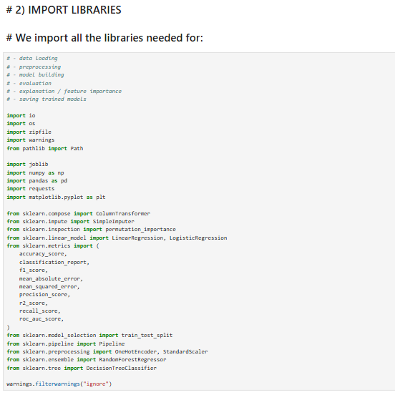
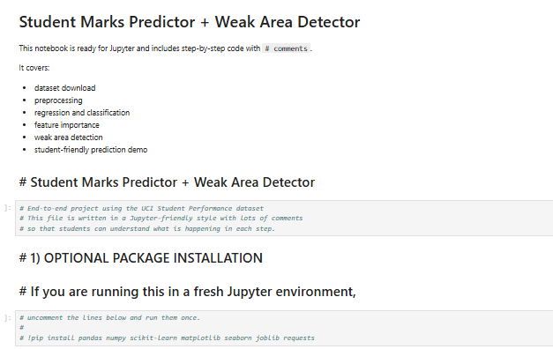
Calculation/Programming
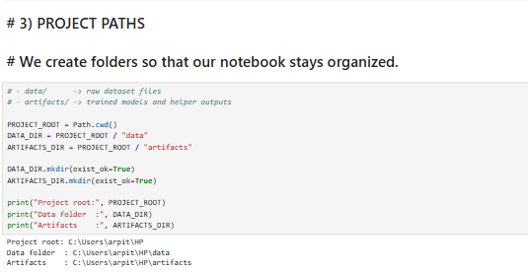

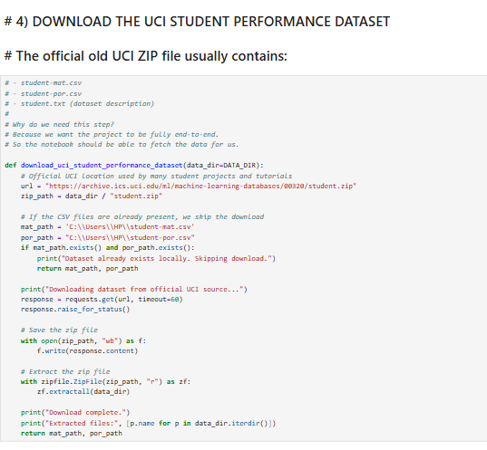

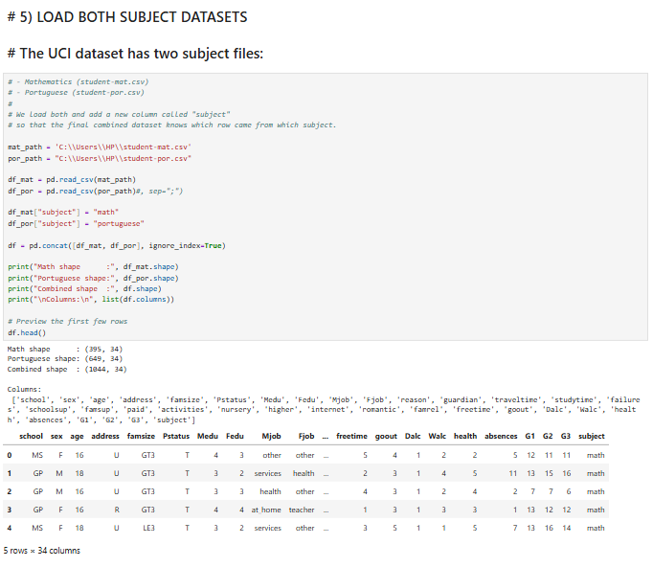
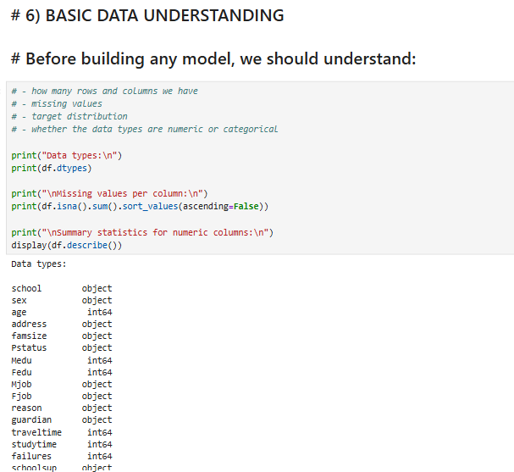
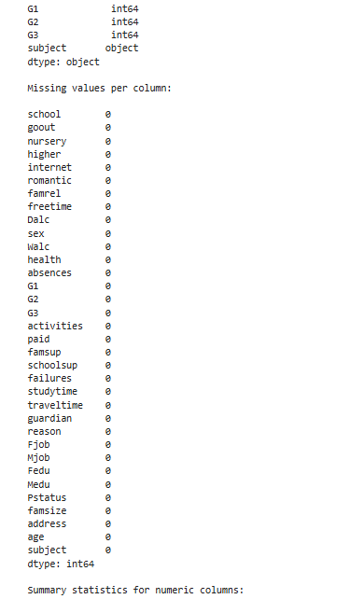
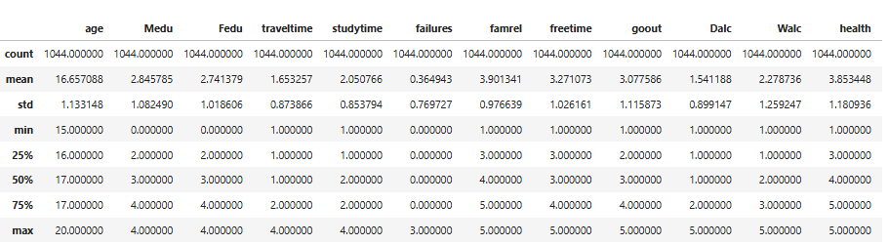
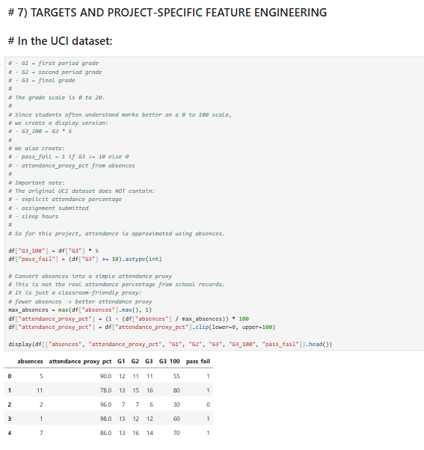

Design/Diagram/Analysis:
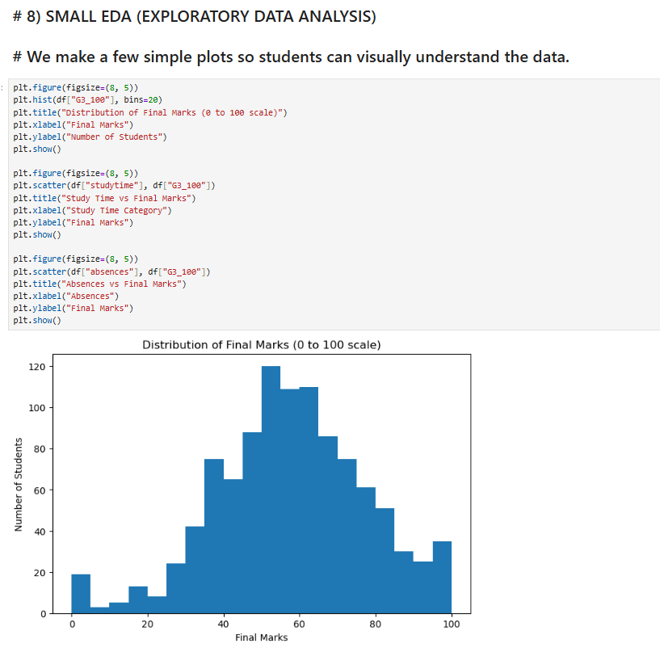

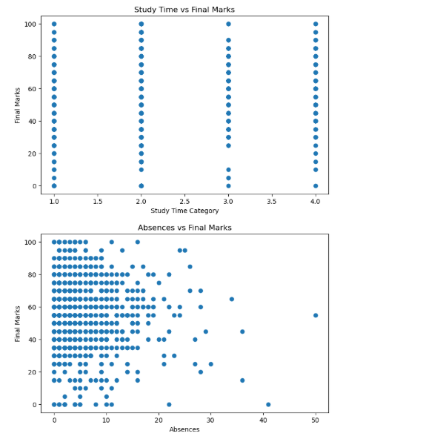
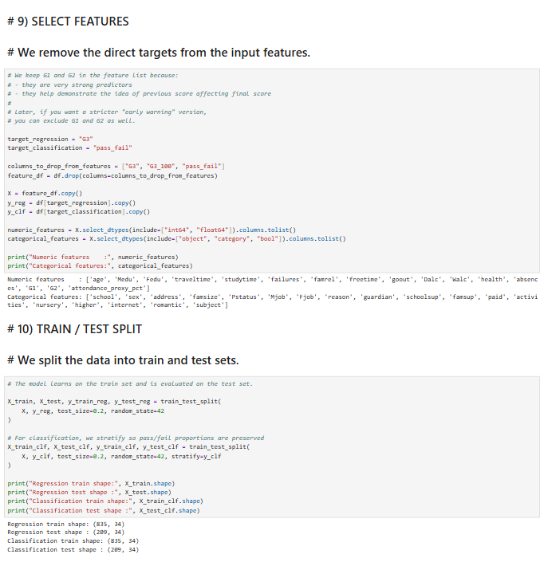
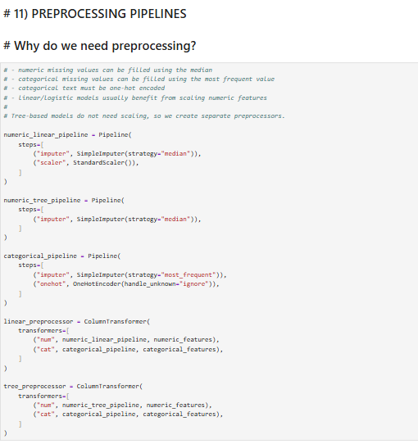
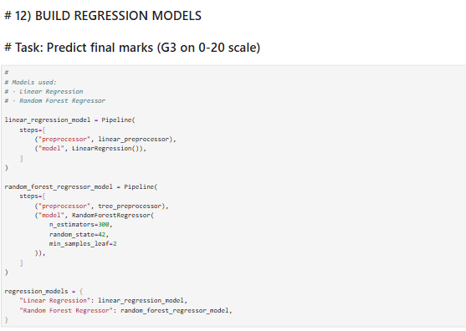
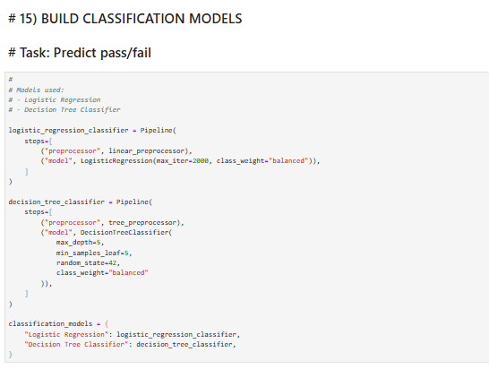
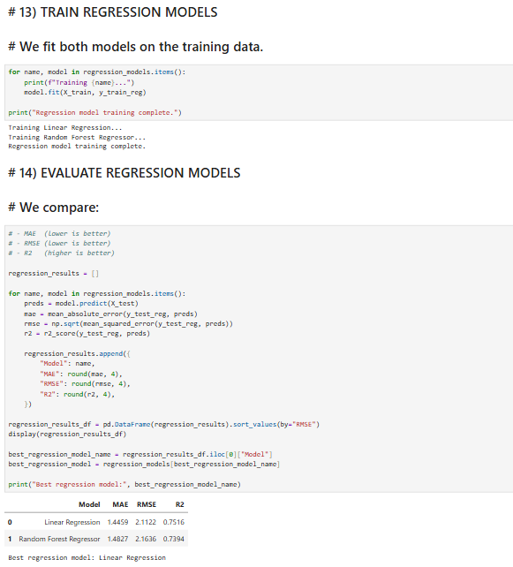
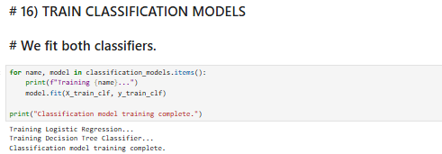
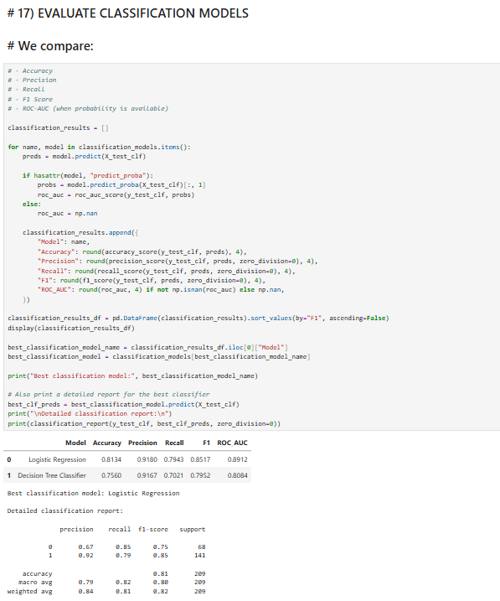

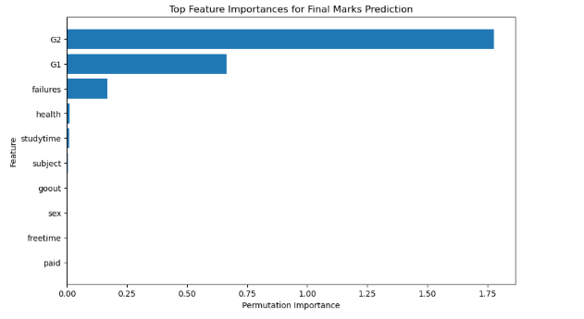
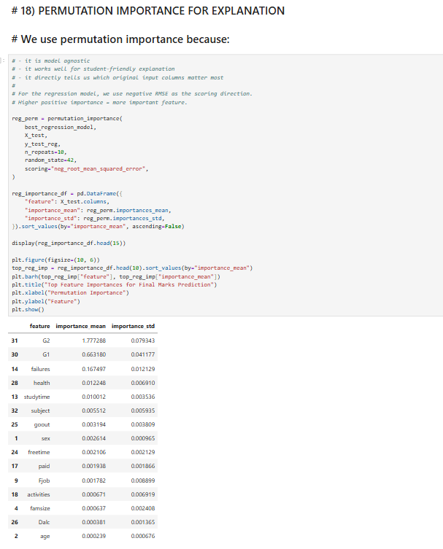
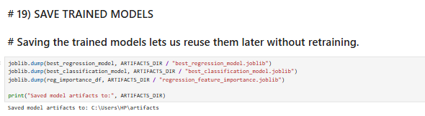
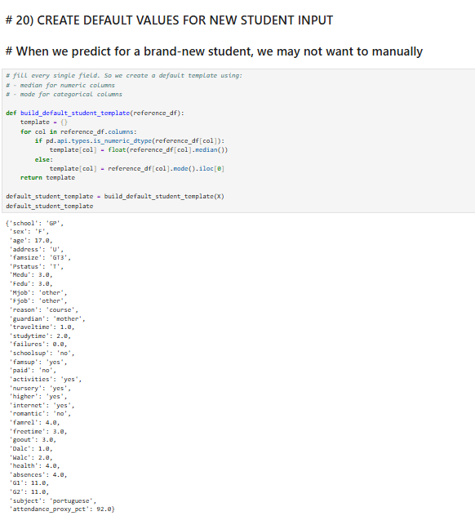

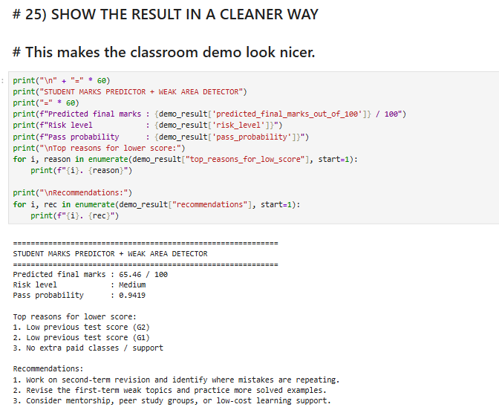
Result:

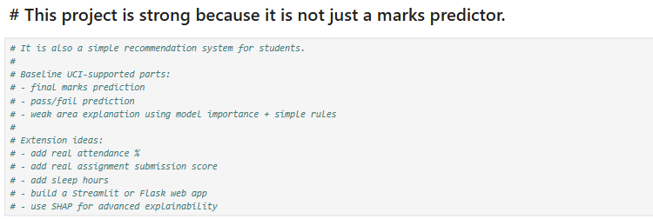

Conclusion :
This is a highly practical, explainable, and interview-worthy machine learning project. Its real strength is not that it predicts marks. Its real strength is that it predicts, explains, and recommends. That turns a simple academic model into a student support system.
If executed carefully, this project can demonstrate:
- Problem understanding
- Data interpretation
- Explainability thinking
- Product design sense
- Real-world educational value

Future scope:
- Add SHAP for better per-student explanation.
- Build semester-wise trend tracking.
- Add topic-level weakness detection from subject marks.
- Include assignment submission rate, sleep hours, screen time, and revision consistency in a custom dataset.
- Deploy as a web app for teachers, parents, or students.
- Add alerting when risk increases over time.
Limitations and Honest Project Boundaries:
- The UCI dataset comes from two Portuguese schools, so generalization to all institutions is limited.
- Some of your desired fields are not directly available in the original dataset.
- Correlation does not automatically mean causal effect.
- Using prior scores can improve accuracy but may reduce early-warning usefulness.
- A predictive system should assist human decision-making, not replace teachers.
- Including limitations makes your report stronger, not weaker. It shows technical honesty.

Reference:

[1] UCI Machine Learning Repository, 'Student Performance,' dataset page and variable description, including tasks, subjects, features, missing-value note, and warning about G1/G2 correlation with G3. DOI: 10.24432/C5TG7T.
[2] P. Cortez and A. M. G. Silva, 'Using data mining to predict secondary school student performance,' Proceedings of the 5th Annual Future Business Technology Conference, 2008.
[3] In this report, custom features such as assignment submission and sleep hours are treated as practical extension ideas rather than fields directly available in the original UCI dataset

Group Photo

